**ATSS’s**

**Institute of Industrial & Computer Management & Research, Nigdi**

**Academic Year 2020-2021**

**MCA I Semester I**

**Mini Project Synopsis**

**Name of the Student: Mandar Rajesh Kate**

**Roll No:80**

**Contact Details** (Contact No. & Email ID)

**Contact No.:9011257067**

**Email ID:** mandarkate2461@gmail.com

**Name of the Student: Manas Mishra**

**Roll No:20**

**Contact Details** (Contact No. & Email ID)**:**

**Contact No.:** 7276608685

**Email ID: manasmi30@gmail.com**

**Title of the Project:** “Film Finder”

**Existing System:**

* Users have to physically choose movies from libraries.
* Options included reading user reviews or randomly selecting a movie.
* Impractical due to the vast number of spectators with diverse movie preferences.
* System suggests to us what to watch without having to put effort into deciding what to watch.

**Need of Proposed System:**

* Hybrid Approach:

Combining both content-based filtering and collaborative filtering techniques. This integration aims to leverage the strengths of each method to provide more accurate and diverse movie recommendations.

* Collaborative Filtering:

To analyze user behavior and preferences. It identifies patterns and similarities between users, recommending movies based on the viewing history and preferences of similar users.

* Content-Based Filtering:

It considers the characteristics of movies, such as genre, director, and actors, to recommend items that are similar to those a user has liked in the past.

* Integration with External Data Sources:

It integrate external data sources, such as movie databases or APIs(TMDB), to enrich its catalog of movies and ensure up-to-date information.

* Comments/Sentiments:

Allowing users to provide explicit feedback on recommended movies.

**Scope of the proposed System:**

* Accurate movie recommendations to users.
* **Goal**: To improve the quality of movie recommendation system, such as accuracy, quality and scalability of system than the pure approaches. This is done using Hybrid approach by combining content based filtering and collaborative filtering,
* Eradicate the overload of the data, recommendation system is used as information filtering tool in social networking sites. Hence, there is a huge scope of exploration in this field for improving scalability, accuracy and quality of movie recommendation systems.

**Objectives of the Proposed System:**

* Improving the Accuracy of the recommendation system
* Improve the Quality of the movie Recommendation system
* Improving the Scalability.
* Enhancing the user experience.
* Collecting Datasets

**Technology used:**

**Frontend:** Html, CSS, Javascript

**Frame Work:** Flask

**Language:** Python 3.11

**API:** TMDB

**Hardware-Software Requirements** (Both- Client & Server Requirements):

Processor: Intel core Processor Pentium 4

Operating System: Windows 7 and Above

RAM: 2GB and Above

Hard Disk: 40GB and Above

**Expected GUI Screens (**List of forms & reports)**:**

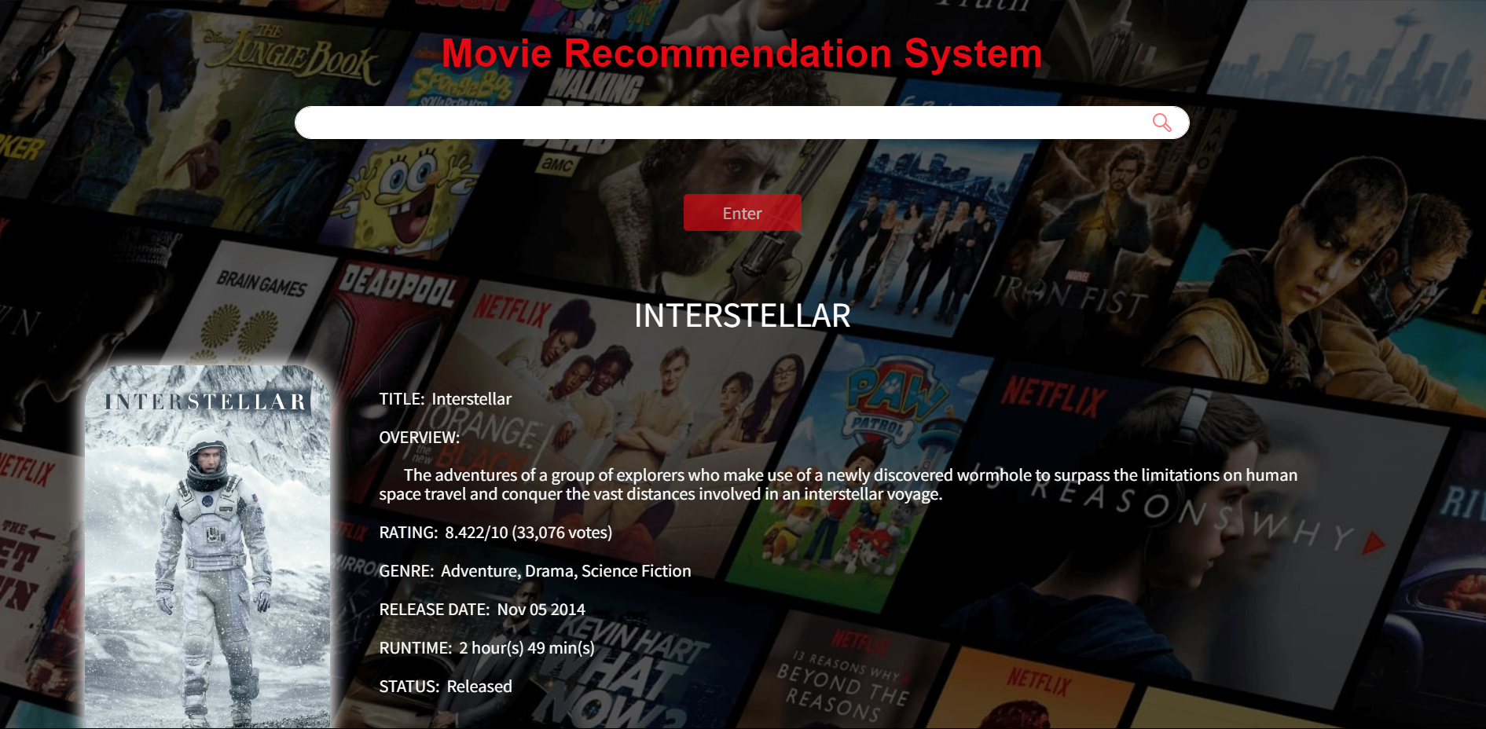

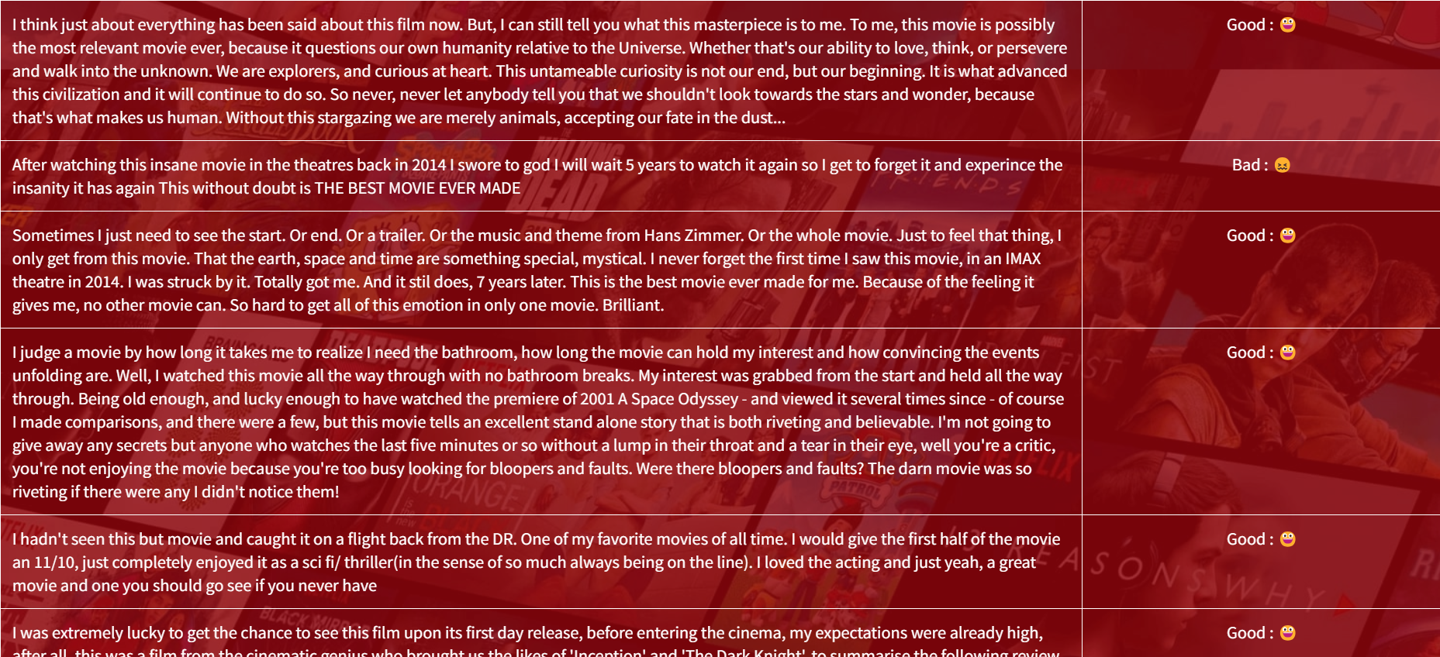

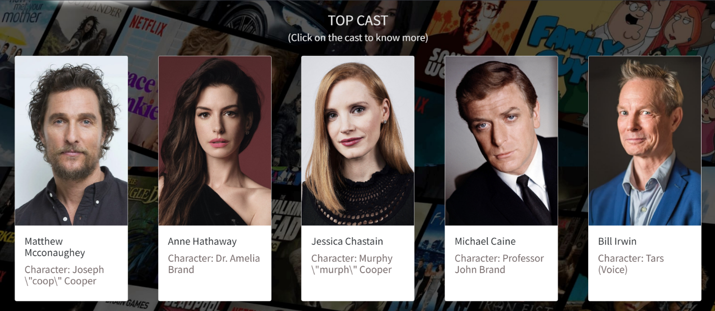

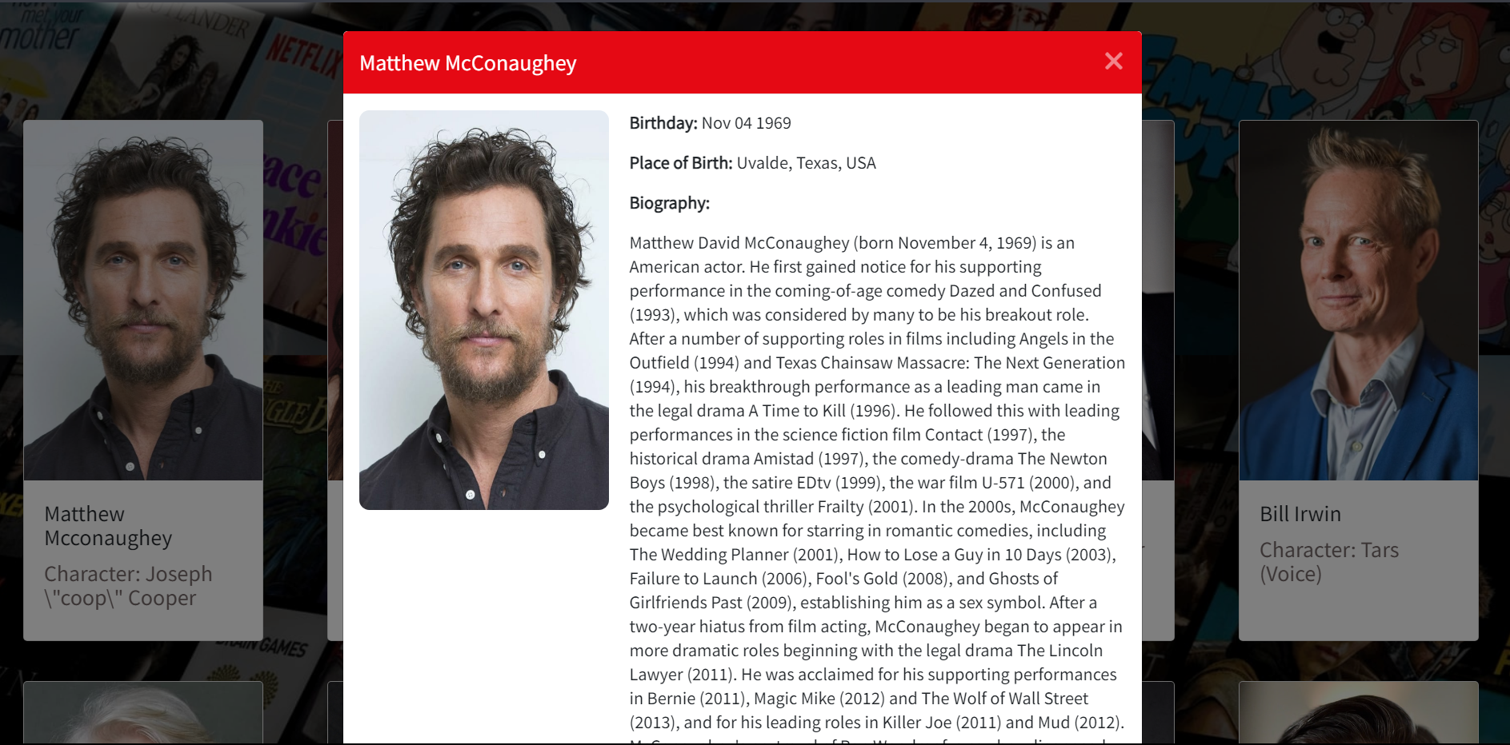

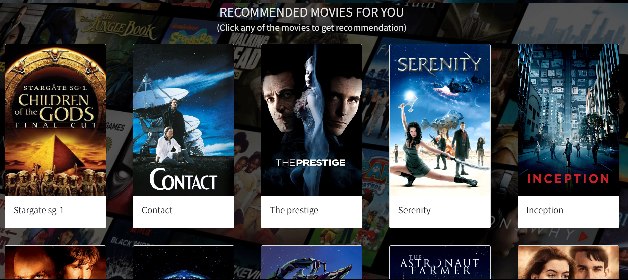

**Forms:**

**Reports:**

Signature of the Student: Date of Submission:

Signature of the Project Coordinator: